**A STUDY OF AN EFFEFCTIVE UTILIZATION OF WASTE PLASTIC IN PAVEMENTS**

**K SHIVANI G TEJASHWINI**

DCE II year IV SEM DCE II year IV SEM

DEPARTMENT OF CIVIL ENGINEERING DEPARTMENT OF CIVIENGINEERING

SREE VISVESVARAYA INSTITUTE OF SREE VISVESVARAYA INSTITUTE OF

TECHNOLOGY AND SCIENCE TECHNOLOGY AND SCIENCE

### ---------------------------------------------------------------------***---------------------------------------------------------------------

**Abstract**

Plastic and polythene are environmentally unacceptable, and so alternative ways have been required to dispose these dangerous things. Hence, there is the need to adopt effective methods to utilize these plastics waste. This present study is a research conducted to study the behavior of Modified Bituminous concrete (BC) mix with polythene waste. In this study various percentage of polythene was used for preparation of mixes with a selected aggregate grading as according to IRC Code. By preparing Marshall Samples of BC mixtures the role of the polythene is studied. Marshall Properties such as stability, flow value, unit weight, air voids are used to determine optimum polythene content for the grade VG30.

***Key words:*** Bituminous concrete (BC), Marshall Stability, optimum polythene content, voids filled bitumen.

1. **Introduction**

In road paving, bituminous binders are widely adopted and the visco-elastic properties of these materials are dependent on their chemical composition. These days, the increase in high traffic intensity in terms of commercial vehicles, and the significant variation in daily and seasonal temperature put us in a situation to think about some of the alternative ways for the improvement of the pavement characteristics and quality. To achieve the present requirement Bitumen can also be modified by adding different types of additives like polythene.

## Problem statement

The availability of plastic waste is enormous today. The use of plastic materials such as carry bags, cups, etc. is increasing day by day. Near about 50% to 60% of total plastic are consumed for packing. Plastic packing materials are thrown outside after one use and so become waste. These types of wastes are durable and non-biodegradable. If these wastes are not disposedproperly then it may cause many hazards to atmosphere. These plastic wastes when get mixed with water, disintegrate, and it takes the form of small pallets which cause the death of fishes and other aquatic life. Sometimes plastic wastes gets mixed with the municipal solid waste or thrown over a land area which is not eco friendly as they pollute the land, air and water. Due to these circumstances, an alternative use of these plastic wastes is required. So it is always welcome any use of plastic waste as a construction material.

## Importance of the study

It is not new to use polythene in road construction. Some aggregates are highly hydrophilic (water loving). Like bitumen, polythene is also hydrophobic (water hating) in nature. So the addition of hydrophobic polythene by dry or wet mixing process to bituminous mix lead to improvement of strength, water repellent property of the mix. Polythene gets added to hot bitumen mixture and the mixture is laid on the road surface like a normal tar road. In the Plastic roads we use plastic carry-bags, disposable cups, polythene packets that are collected from garbage as important ingredients of the construction material. To improve the fatigue life, reduce the rutting & thermal cracking in the pavement it is necessary to go through polymer modification processes.

## Material used

* 1. **Aggregates**

The various types of mineral aggregates obtained from different natural sources used to manufacture bituminous mixes. To achieve good performance characteristics the aggregates can be further processed and finished. In order to enhance the characteristics of mix industrial by-products such as steel slag, blast furnace slag, fly ash etc. sometimes used by replacing natural Aggregate. This contributes up to 90-95 % of the mixture weight and contributes to most of the load bearing & strength characteristics of the mixture.

Therefore, the quality and physical properties of the aggregates should be controlled to ensure a good pavement.

|  |  |  |
| --- | --- | --- |
| **Table 1: Physical properties of course aggregates** | | |
| **Property (%)** | **Test Method** | **Test Result** |
| Aggregate impact value | IS:2386 | 14.3 |
| Aggregate crushing value | IS:2386 | 13.02 |
| Los Angeles abrasion value | IS:2386 | 18 |
| Flakiness index | IS:2386 | 18.83 |

## GYAN MILK Polythene

In this study the GYAN MILK Polythene is used as stabilizing additive. GYAN MILK is a local brand of Gorakhpur city and hence the polythene used for milk packaging is locally available. The GYAN MILK Polythene packets were collected, washed and cleaned by putting them in hot water for about 4-5 hours. After that they were dried. After drying the packets were cut into the smaller uniform pieces. This ensures the uniform size of the polythene in the bitumen mix. Mixing should be proper while adding the polythene to bitumen and aggregates. The specific gravity of polythene was found 0.90

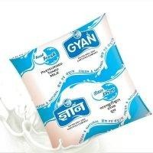

|  |  |
| --- | --- |
| Displacement at peak | 120.15mm |
| Load at peak | .140Kn |
| Stress at peak | 13.00Mpa |

## Preparation of sample

The mixes were prepared according to the Marshall Test procedure. The required quantities of course aggregates, fine aggregates & fillers were taken in an iron pan and kept in an oven at a temperature of 160°C for about 2 hours. The aggregates and bitumen are mixed in heated state, hence preheating is required. Required amount of shredded polythene was weighed and kept in another container. The aggregates in pan were heated at 160°C for a few minute and then the polythene was added to aggregates and mixed for 2 minutes. Next, bitumen was added to mix and the whole mix was stirred for 15-20 minutes to make a proper uniform and homogenous mix which was evident from uniform color throughout the mix. After that the mix was transferred to a casting mould. 75 numbers of blows were given each side of the sample hence making total 150 numbers of blows per sample. Then each sample was marked and kept separately.

## Marshall Test

In Marshall Test, the machine has strained controlled loading unit to move the base plate at the rate of 51mm per minute. The test head with the specimen is placed over the base plate and the dial gauge is set to measure the vertical deformations of the specimen during loading. It is very popular method in India for characterization of bituminous mixes due to its low cost and simplicity. The maximum load reading and corresponding deformation of the specimen at failure load are noted. The maximum load expressed in Kg as a Marshall Stability value and the vertical deformation of the test specimen corresponding to the maximum load in mm units recorded as flow value.

|  |  |
| --- | --- |
| **Table 2: Physical properties of GYAN MILK Polythene** | |
| **Properties** | **Result** |
| Specific gravity | 0.90 |
| Young modulus | 109.75Mpa |
| Softening point | 54.22 °C |
| Strain at break | 1300 % |
| Strain at peak | 1200 % |
| Displacement at break | 130.15mm |

## Experimental results

In this present investigation the Marshall properties such as stability, flow value, unit weight, voids in mineral aggregate and air voids were studied to obtain the optimum polythene content (OPC) and optimum binder content (OBC).

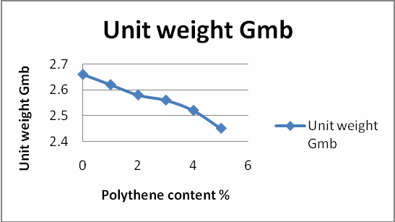Based on the results there are following five curves plotted i.e.

1. Marshall stability value vs. polythene content
2. Marshall flow value vs. polythene content
3. VMA vs. polythene content
4. VA vs. polythene content
5. VFB vs. polythene content
6. Bulk unit weight vs. polythene content

In this study each % of polythene, three samples have been tested. Hence the average values of three were taken. The average value are shown in following table 3

|  |  |  |  |  |  |  |
| --- | --- | --- | --- | --- | --- | --- |
| **Table 3. Data for plotting curves** | | | | | | |
| **Polythene content**  **%** | **Unit weight (Gmb)** | **Mean VMA (%)** | **Mean VA (%)** | **Mean VFB (%)** | **Mean s (kN)** | **Mean f (mm)** |
| 0 | 2.66 | 16.24 | 4.89 | 69.86 | 14.35 | 4.06 |
| 1 | 2.62 | 15.08 | 3.79 | 74.86 | 14.26 | 3.8 |
| 2 | 2.58 | 14.21 | 3.02 | 78.88 | 14.55 | 3.13 |
| 3 | 2.56 | 13.87 | 2.83 | 79.56 | 15.54 | 2.96 |
| 4 | 2.52 | 13.61 | 2.73 | 79.92 | 17.72 | 2.86 |
| 5 | 2.45 | 13.21 | 2.47 | 81.27 | 15.94 | 3 |

**Figure-1:** Marshall Stability value vs. Polythene content



**Marshall Stability value**

20

15

10

5

0

Marshall

stability

value

0 2 4 6

**Polythene content %**

**arshall stability value kN**

### **Figure-2**: Unit weight value vs. Polythene content

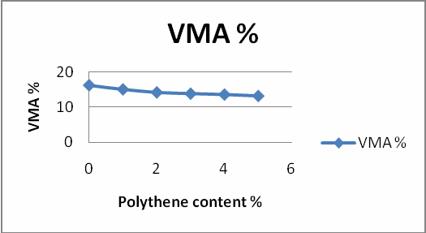

**Figure-3**: VMA vs. Polythene content

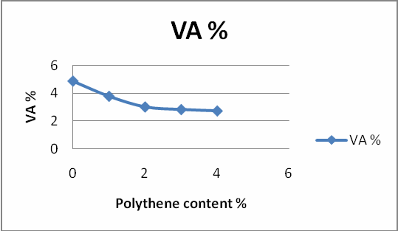

**Figure-4:** VA vs. Polythene content

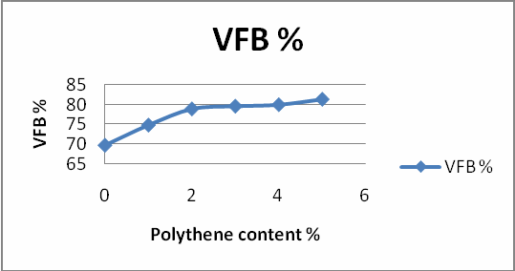

**Figure-5:** VFB vs. Polythene content

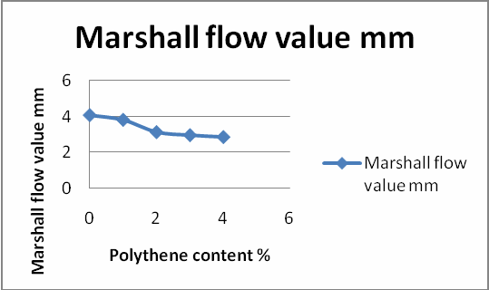

### **Figure-6:** Marshall flow value vs. Polythene content

1. **Result analysis**

The properties of bitumen binders were improved by introducing polythene. The value of polythene content at which the sample has maximum Marshall stability value and minimum Marshall flow value is called optimum polythene content and is found to be 4%. The study shows that the addition of polythene decreases the voids present in mix. From the figure 6 we observe that Marshall Flow value decreases upon addition of polythene which shows that resistance to deformations under heavy wheel loads increases.

## Conclusion

From the above observation it is calculated that use of waste polythene results in improved engineering properties of bituminous mix. Therefore this study explores the utilization of waste plastic and also provides an opportunity to construct an improved pavement material in surface course thus making it more durable. It is observed that Marshall Stability value increases with polythene content up to 4% and then decreases .this investigation also studied that the

Addition of polythene decreases the Marshall Flow value. This shows the resistance to deformation under heavy wheel loads keeping the value of parameter like VMA, VA, VFB is within required specification. Using modified polymer could be a boon to construction technology. In India where temperature rises up to 50°C, this adversely affects the life of pavement. The modified polymer bitumen shows improved property of pavement. In the modification process plastic waste is coated over aggregate which increase the surface area of contact and ensure better bonding between aggregate and bitumen. Hence taking into account all these consideration we can conclude that we can obtain a more stable and durable mix for the pavement by polymer modification. It will add the value of plastic as well as develop a technology which is eco friendly.